Project Proposal (CSC 542/642)
Predicting NFL Performance based on College Statistics and Athletic Test Results
Repository
Danny Harlan, Brandon Schoenwether, and Jennifer Rogers

Introduction
Projecting whether a college football player will succeed in the National Football League (NFL) remains one of the most difficult and consequential problems in sports analytics. NFL teams invest substantial financial and organizational resources into draft decisions yet translating college production and pre-draft testing into professional success is far from straightforward. A strong draft selection can improve a franchise for years, whereas a poor selection can lead to lost cap space, missed opportunities, and reduced competitive performance.
Player evaluation is a complex decision-making process that combines factors such as on-field performance, physical attributes, and contextual considerations, including competition level, role, injuries, and development. Despite the amount of effort and money devoted to scouting and personnel analysis, teams still face considerable uncertainty in determining how a college player will perform at the professional level. Much of this difficulty likely results from the inability to fully capture the interaction of environmental, organizational, and personal factors that shape long-term NFL success. For this reason, developing methods that improve draft forecasting remains an important problem for professional organizations and the sports analytics community.
This project examines whether pre-draft information can be used to predict future NFL success. Specifically, it combines college performance statistics, NFL Combine measurements, and draft-related variables to model whether a player achieves a relatively high level of professional performance. Rather than relying only on traditional box-score outcomes, the study defines success using Pro Football Focus (PFF) grades, which evaluate individual player performance on a play-by-play basis and therefore provide a more granular measure of contribution.
The project addresses two related research questions:
- How accurately can college statistics and other pre-draft indicators predict NFL success?
- Which features appear most associated with success within different position groups?
The primary emphasis of this final report is the first question: building and evaluating predictive models. The second question remains an important direction for feature interpretation and future analysis.
This problem is important for both practical and methodological reasons. From a practical standpoint, even modest improvements in draft forecasting could help teams allocate resources more effectively and reduce the cost of poor selections. From a methodological standpoint, the task is difficult because professional performance is influenced by many interacting factors, including position-specific skill sets, coaching context, injuries, developmental trajectory, and scheme fit. As a result, this project provides a useful setting for studying how much predictive value can be extracted from pre-draft data alone.
State-of-the-Art
Previous research on NFL draft forecasting has often concentrated on narrow predictor sets, particularly NFL Combine measurements. One of the foundational studies in this area, Kuzmits and Adams (2008), examined whether combine testing predicts NFL performance and found that physical testing alone has limited predictive value for many player groups. Their results suggest that combine metrics may contain useful information, but they are generally insufficient as standalone predictors of professional success.
Subsequent research moved toward more specialized, position-focused models. Studies such as Boulier et al. (2010), Wolfson et al. (2011), and Winchester and Craig (2020) explored prediction problems for selected positions, especially quarterbacks and skill-position players. These studies demonstrated that prediction quality can vary substantially by position and that position-specific modeling is often more appropriate than a single model for all players.
More recent work has incorporated machine learning techniques into sports decision-making. Enaganti and Pappas (2025) applied classification methods such as logistic regression, random forests, and gradient boosting to study NFL draft optimization. These methods are appealing because they can capture nonlinear effects and interactions among predictors that simpler models may miss. This reflects a broader shift in sports analytics toward more flexible predictive frameworks.
Even with these advances, two important gaps remain. First, much of the literature still relies on traditional outcome measures such as touchdowns, passing yards, rushing yards, or honors and awards. While useful, these outcomes do not always capture the full value of players whose contributions are less visible in conventional box scores, such as offensive linemen or some defensive roles. Second, many studies focus only on selected positions or only on one side of the ball.
This project contributes to that literature in two ways. First, it uses PFF grades as the outcome measure, which provides a more individualized and play-level representation of performance. Second, it applies position-specific classification models across both offense and defense, allowing the analysis to reflect the fact that the determinants of success differ substantially across positions.
Materials and Methods
Dataset: The dataset used in this project was created by merging multiple football data sources
containing publicly available college football performance metrics, NFL Combine performance, draft information, and PFF-based NFL performance measures. The data mostly came from PFF where we downloaded and merged years of data (dozens of separate downloads) because PFF splits up their files by year and play types. We also used a couple of Kaggle datasets for combine performance and draft information. The merged file contains slightly more than 2,000 player observations and nearly 2,000 variables.
A key preprocessing step addressed differences in college career length. Because some players enter the draft after three seasons while others remain in college for four or five seasons, the raw season-by-season variables were transformed so that each player had one comparable set of final-college-season statistics. In the merged dataset these variables appear under the last_..._ncaa__... naming structure. This approach standardizes players by using the most recent available college performance values rather than an arbitrary season number. Additional preprocessing included converting combine height from a feet-inch string format into total inches and creating the binary response variable used in the classification models.
For modeling purposes, players were separated into offensive and defensive groups, and then further divided into position-specific subgroups. This was necessary because the relevant college statistics differ substantially across roles. For example, coverage variables are meaningful for defensive backs but not for defensive linemen, while passing efficiency variables are meaningful for quarterbacks but not for offensive linemen.
Methods
The primary modeling approach used in this project is logistic regression, implemented as a baseline method for binary classification. For each player, the response variable is defined as
$Y_{i}=\{1, if the player’s overall NFL PFF grade is ≥75 0, if the player’s overall NFL PFF grade is <75$
A threshold of 75 was selected to identify players who achieved a relatively strong level of professional performance.
For each positional group, the model estimates the probability of success as
$P(Y_{i}=1∣X_{i})=\frac{1}{1+e^{-(β_{0}+β_{1}x_{i1}+⋯+β_{p}x_{ip})}}$
where $X_{i}$ is the vector of predictors for player $i$, $β_{0}$ is the intercept, and $β_{1},…,β_{p}$ are the estimated coefficients.
Rather than fitting a single model across all players, the analysis uses separate models by position group. This decision reflects the fact that football positions depend on different skill sets and therefore require different predictor sets. The offensive models were estimated for:
The offensive models were built for: Quarterbacks (QB), Running Back (RB), Wide Receiver (WR), Tight End (TE), Offensive Line (OL; offensive tackle, guard, and center combined).
The defense models were built for: Defensive Line (DL; includes edge defenders and interior linemen), Linebacker (LB), and Secondary (Sec; including cornerbacks and safeties).
Each positional model used a subset of predictors relevant to that role. Across groups, predictors were drawn from three main categories: college performance statistics, NFL Combine measurements, Draft context measures.
The exact feature sets were tailored to each role. For example, quarterback models emphasized passing-related variables, while running back models focused more on rushing efficiency and related production measures. Offensive line models relied more heavily on physical attributes and draft information because position-specific box-score statistics are more limited. On defense, the revised feature sets were restricted to pre-draft variables only in order to avoid information leakage.
Before estimation, predictors were standardized using the training data so that variables measured on different scales would contribute more comparably to the model. Predictors with zero variance within a positional subgroup were removed before fitting to avoid singularity and instability.
Logistic regression was selected because it offers a clear and interpretable baseline for binary classification. It estimates the probability that a player reaches the high-performance threshold using pre-draft information and provides a straightforward starting point for later comparison with more flexible approaches.
Evaluation
Model performance was evaluated using a hold-out testing framework combined with cross-validation. The full dataset was split into 80% training data and 20% testing data. The training set was used for model estimation and cross-validation, while the test set was reserved for final performance assessment. This approach helps separate model development from final evaluation and reduces the risk of overstating predictive performance.
Within the training data, 5-fold cross-validation was used to assess model stability. For some parts of the pipeline, stratified cross-validation and log-loss were also considered as robustness checks because the positive class was relatively rare.
Table 1: Offense Dataset Size and Class Balance
Dataset Size |  | Class Balance
 |  | Position | Train Neg | Train Pos | Test Neg | Test Pos
Off. Total | 808 | QB | 50 | 9 | 18 | 4
Training | 646 | RB | 90 | 18 | 22 | 6
Test | 162 | WR | 154 | 28 | 37 | 2
 |  | TE | 66 | 4 | 20 | 2
 |  | OL | 197 | 29 | 48 | 3

Table 2: Defense Dataset Size and Class Balance
Dataset Size |  | Class Balance
Def. Total | 979 | Position | Train Neg | Train Pos | Test Neg | Test Pos
Training | 783 | Def. Line | 277 | 34 | 71 | 6
Test | 196 | Linebacker | 145 | 13 | 26 | 3
 |  | Secondary | 283 | 31 | 84 | 6

Since the outcome is binary, the models were evaluated using classification metrics rather than regression metrics. The main evaluation tools included: confusion matrices, accuracy, precision, recall, F1 score, Area Under the ROC Curve (AUROC), Area Under the Precision-Recall Curve (AUPRC).
These metrics are especially important because the dataset is strongly imbalanced. Only about 10% of players in the dataset achieved a PFF grade of 75 or higher. In such settings, accuracy alone can be misleading, since a model can achieve high accuracy while rarely identifying the minority class. For that reason, the interpretation of model performance emphasized precision, recall, F1 score, and ranking-based metrics such as AUROC and AUPRC in addition to overall accuracy.

Results
Descriptive analysis
The dataset contains approximately 2,000 players, and only about 10% of them achieved the high-performance threshold of a PFF grade of 75 or higher. This strong class imbalance is one of the main challenges of the project. The overall distribution of NFL grades is concentrated at lower values and is not symmetric, which supports the decision to model a binary high-performance outcome rather than treating the first-stage analysis as a purely continuous-outcome regression problem.
The descriptive analysis also reinforces the practical difficulty of the task: most drafted players do not go on to become high-end NFL performers by the PFF threshold used in this study. As a result, the modeling problem is best interpreted as a rare-event classification problem.
Figure 1: Distribution of Overall NFL Grades
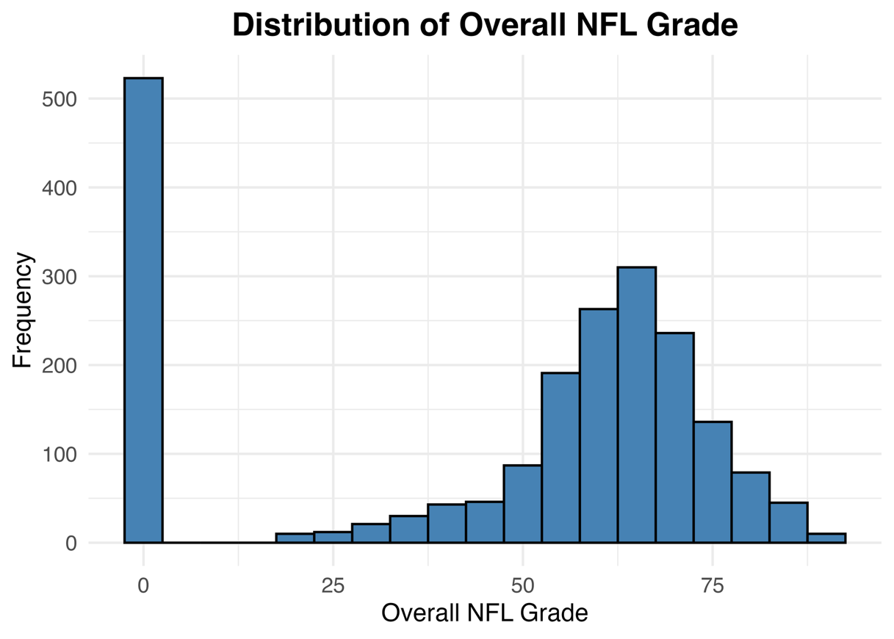
The distribution of overall NFL grades supports the use of a binary high-performance outcome. A substantial portion of observations fall in the lower range, while relatively few players reach the $75+$threshold. This makes predicting whether a player reaches a strong performance benchmark a more meaningful first step than modeling the outcome as a continuous response in the baseline analysis.
Baseline Results from the First Submission
The first submission reported position-specific logistic regression results primarily through test accuracy, AUC, and cross-validation summaries. These baseline results are shown in Table 3.
Position | Test Accuracy | AUC | CV Metric
QB | 0.864 | 0.792 | 0.168
RB | 0.786 | 0.712 | 0.146
WR | 0.949 | 0.703 | 0.130
TE | 0.909 | 0.550 | 0.061
OL | 0.941 | 0.819 | 0.108
DL | 0.922 | 0.775 | 0.106
LB | 0.828 | 0.628 | 0.136
SEC | 0.911 | 0.700 | 0.113
Table 3: First-submission baseline logistic regression results.

On offense, the offensive line model showed the strongest baseline discrimination by AUC ($0.819$), followed by quarterback ($0.792$). On defense, the defensive line model showed the strongest baseline AUC ($0.775$). Some groups, such as wide receiver and tight end, posted high test accuracy but less convincing AUC values, suggesting that class imbalance may have made accuracy appear stronger than the actual discriminatory power of the models. These results establish that pre-draft information contains some signal, but the strength of that signal varies across positions.
Updated Position-Level Classification Results
The updated presentation retained the same position-specific logistic regression framework but evaluated the models more explicitly with confusion matrices, precision, recall, and F1 score. These threshold-based metrics provide a clearer view of how the models perform on the minority class.
Table 4 : Position-level classification results
Position | Accuracy | Precision | Recall | F1 Score
QB | 0.91 | 1.00 | 0.50 | 0.67
RB | 0.71 | 0.38 | 0.50 | 0.43
Position | Accuracy | Precision | Recall | F1 Score
WR | 0.79 | 0.13 | 0.50 | 0.20
TE | 0.91 | 0.50 | 0.50 | 0.50
OL | 0.80 | 0.11 | 0.33 | 0.17
DL | 0.89 | 0.25 | 0.25 | 0.25
LB | 0.90 | 0.00 | 0.00 | N/A
SEC | 0.88 | 0.25 | 0.17 | 0.20

Among the offensive groups, quarterback showed the strongest overall balance of metrics, with high accuracy and the best F1 score. The quarterback model also achieved perfect precision on the evaluated predictions, although recall remained moderate, indicating that the model identified only part of the successful cases. Tight end also performed reasonably well by threshold-based metrics, although that result should be interpreted cautiously because the positive class for tight ends was very small. Running back showed moderate predictive ability, while wide receiver, offensive line, secondary, and especially linebacker had difficulty identifying successful player reliability.
The linebacker model failed to recover any true positives in the reported threshold-based evaluation, illustrating how small subgroup size and heavy class imbalance can produce unstable or weak minority-class performance. Overall, these threshold-based results reveal an important pattern: high accuracy does not necessarily imply strong predictive performance. Several models achieved relatively high accuracy largely because the negative class dominates the data, but their lower precision, recall, and F1 scores show that correctly identifying successful players remains difficult.

Confusion Matrix Interpretation
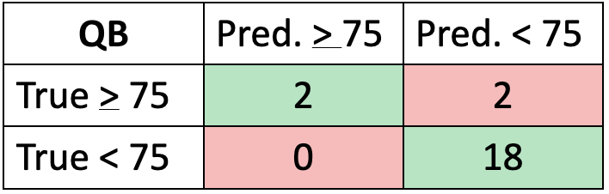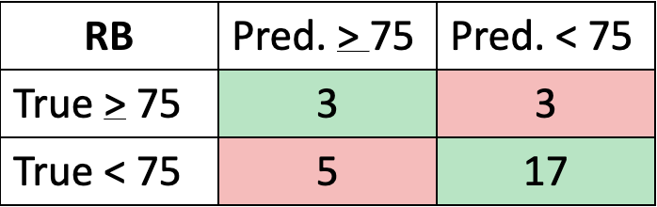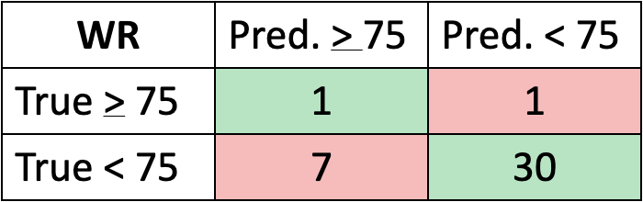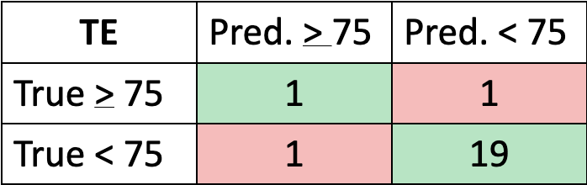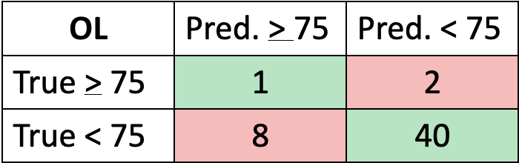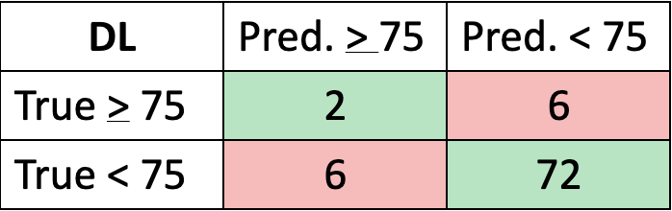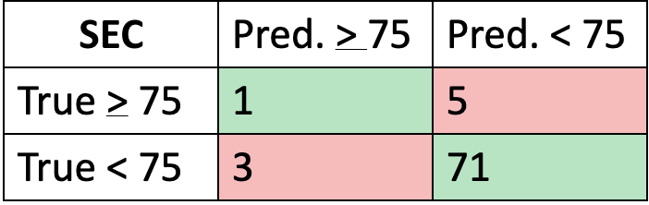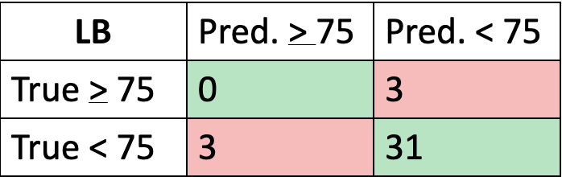
The confusion matrices above for each position further illustrate the effect of class imbalance. For several position groups, the models correctly classified many negative cases but missed a nontrivial share of the positive cases. This indicates that the models were generally more effective at predicting which players would not reach the success threshold than at detecting which ones would.
Overall Discrimination Results: AUROC and AUPRC
Because the threshold-based metrics in Table 4 depend on a specific classification cutoff, the analysis also evaluated model discrimination across thresholds using AUROC and AUPRC. In the presentation, these metrics were reported at the overall offense and overall defense level rather than by individual position. For that reason, they are presented separately from the position-level classification table.
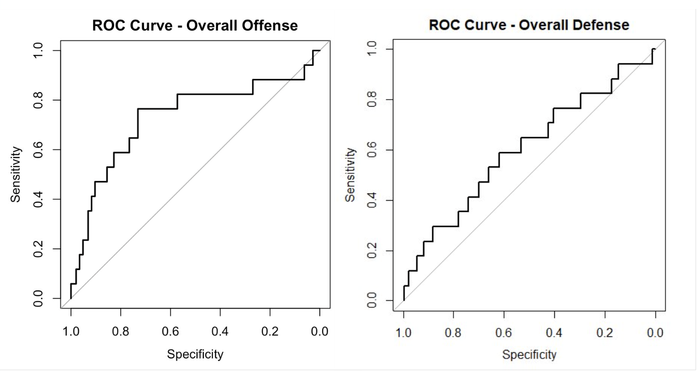
Figure 2 shows the ROC curves for the aggregated offensive and defensive predictions. In both cases, the ROC curves lie above the diagonal reference line, indicating better-than-random discrimination across thresholds. These curves summarize how well the models rank successful players above unsuccessful ones independent of a single cutoff.
The overall offensive model achieved an AUROC of 0.731, while the overall defensive model achieved an AUROC of 0.611. The offensive models were more capable of dissociating players with draft grades above and below 75 than the defensive models.
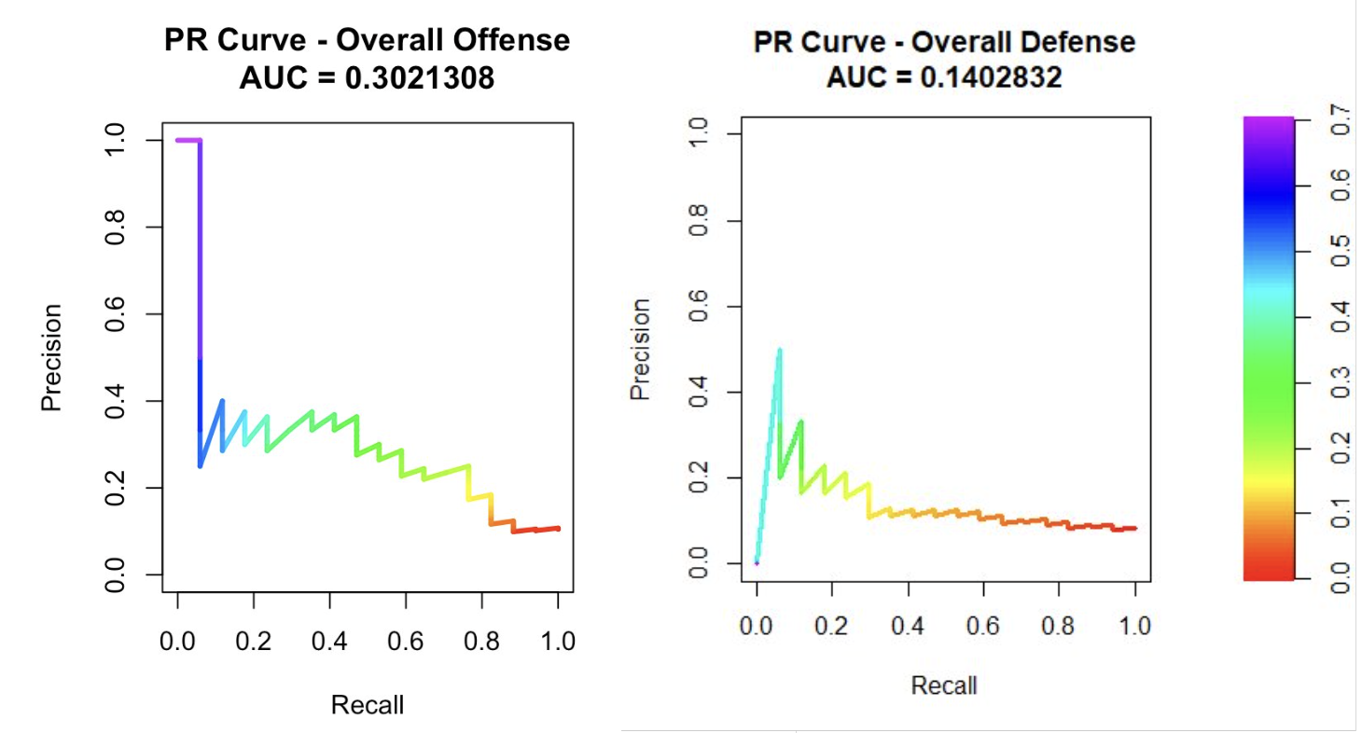
Figure 3 presents the precision-recall curves for the aggregated offensive and defensive predictions. These curves are especially important in this project because the positive class is rare. Compared with ROC curves, precision-recall curves provide a more realistic view of how well the models detect high-performing players when successful cases make up only a small share of the sample.
The ROC and precision-recall analysis support the same general conclusion as the threshold-based metrics. The models contain useful predictive signal, but performance remains limited by class imbalance and by the fact that many determinants of NFL success are not fully captured by pre-draft variables alone.
Comparative Summary of Findings
Because the first submission emphasized ranking-based discrimination measures such as AUC, while the updated presentation placed greater emphasis on threshold-based classification metrics such as precision, recall, and F1, model quality is compared across both stages to provide a more complete assessment of performance.
Table 5: Comparative Summary of Positional Logistic Regression Performance
Position | 1st Submission Test Accuracy | 1st Submission AUC | Presentation Accuracy | Presentation F1 | Comparative Summary
QB | 0.864 | 0.792 | 0.91 | 0.67 | Strong in both stages; best threshold-based model overall
RB | 0.786 | 0.712 | 0.71 | 0.43 | Moderate performance across both stages
WR | 0.949 | 0.703 | 0.79 | 0.20 | High baseline accuracy overstated true performance
TE | 0.909 | 0.550 | 0.91 | 0.50 | Stable accuracy, but discrimination remains mixed
OL | 0.941 | 0.819 | 0.80 | 0.17 | Best baseline AUC overall, but weaker at default cutoff
DL | 0.922 | 0.775 | 0.89 | 0.25 | Best defensive baseline model
LB | 0.828 | 0.628 | 0.90 | N/A | Most difficult subgroup; very weak positive-class detection
SEC | 0.911 | 0.700 | 0.88 | 0.20 | Moderate ranking ability, weak threshold performance

If the preferred metric is AUC, the offensive line model was the strongest overall baseline model, while defensive line was the strongest baseline model on defense. If the preferred metric is F1 score, the quarterback model performed best under the updated threshold-based evaluation. This comparison shows exactly why accuracy alone is not sufficient in this project. Some models appear strong by accuracy but perform much more modestly when evaluated on their ability to detect the minority class directly.
The results suggest that pre-draft indicators contain useful but limited predictive information. The models extract signal, but that signal differs considerably by position. This supports the use of position-specific modeling rather than a single pooled classifier.
The comparison between the first submission and the presentation also shows that the way performance is evaluated matters a great deal. In the earlier baseline stage, several models appeared strong when judged primarily by accuracy. In the updated analysis, however, precision, recall, F1, AUROC, and AUPRC provide a more realistic interpretation of model quality under severe class imbalance.
Overall, the strongest evidence from both stages suggests that quarterback, offensive line, and defensive line are the most promising groups for prediction using the current feature set, while linebacker remains especially difficult to model with the available pre-draft variables.
Conclusions and Future Work
This project examined whether college performance statistics, NFL Combine measurements, and draft-related variables can be used to predict NFL success as measured by Pro Football Focus grades. Using position-specific logistic regression models, the analysis found that pre-draft data contain some predictive value, but that value is uneven across positions and limited by strong class imbalance.
The first submission established a baseline logistic regression framework and showed that some positional models—particularly offensive line and defensive line by AUC, and quarterback by overall balance of performance—captured meaningful signal. The updated presentation improved the interpretation of results by incorporating confusion matrices, precision, recall, F1 score, AUROC, and AUPRC. Those updated metrics made clear that several models with high accuracy still struggled to identify the minority class of high-performing players.
The project therefore supports two main conclusions. First, pre-draft variables are informative but not sufficient for fully explaining professional success. Second, position-specific modeling is necessary, since different groups exhibit quite different predictive patterns.
Several limitations remain. The outcome is highly imbalanced, with only about 10% of players reaching the 75% threshold. Some position groups also contain relatively few positive cases, which limits model stability. In addition, the models rely only on pre-draft information and therefore exclude many factors that are likely to influence NFL outcomes, such as coaching quality, injuries, developmental environment, and team or scheme fit.
Future work should build on this baseline in several ways. Explore class-imbalance strategies, such as down sampling the majority class, using class weights, or testing alternative thresholds. Evaluate more flexible models, including random forests, gradient boosting, and other ensemble methods, to determine whether nonlinear effects and interactions improve prediction. Expand feature engineering and move further into the second research question by identifying which pre-draft variables are most associated with success at each position. Examine whether broader changes in college football, including NIL, alter long-term draft evaluation patterns.
In summary, the study shows that draft forecasting is possible to a limited extent, but it also confirms that NFL success is shaped by more than pre-draft numbers alone. The logistic regression framework provides a useful and interpretable baseline, while the updated evaluation highlights exactly where the current models succeed and where they still fall short.

Works Cited
Boulier, B. L., Stekler, H. O., Coburn, J., & Rankins, T. (2010). Evaluating National Football League draft choices: The passing game. International Journal of Forecasting, 26(3), 589–605. https://doi.org/10.1016/j.ijforecast.2009.10.009

Enaganti, A., & Pappas, G. (2025). Optimizing NFL draft selections with machine learning classification. AI, 6(9), 221. https://doi.org/10.3390/ai6090221

Kuzmits, F. E., & Adams, A. J. (2008). The NFL combine: does it predict performance in the National Football League?. Journal of strength and conditioning research, 22(6), 1721–1727. https://doi.org/10.1519/JSC.0b013e318185f09d

Winchester, D., & Craig, B. A. (2020). Predicting National Football League success: Defensive players. Journal of Quantitative Analysis in Sports, 16(1), 1–15. https://doi.org/10.1515/jqas-2019-0030

Wolfson, J., Addona, V., & Schmicker, R. (2011). The National Football League draft: A study of the efficacy of the NFL draft. Journal of Quantitative Analysis in Sports, 7(2), Article 10. https://doi.org/10.2202/1559-0410.1364

